**Photos- Website to upload and view photos**

Design Document

Pallabi Chakraborty, University ID: N14666839

**Abstract**

This document provides an overview on the setup, design and running of the Photos Website

Table of Contents

1. Programming Language used 3

2. Features Implemented 3

View Photos 3

Upload Photos 4

User Photo Page 5

Details Page 6

Login and Registration Forms 6

Admin Console 7

3. Setup and Running of the code 8

3.1 Run the code 8

4. Overview of the Design 10

5. Code Walkthrough 10

6. References 14

# Programming Language used

The website has been developed using Python employing Django Framework.

The development environment specifications are as follows:

Python – Version 2.7.10

Django – Version 1.11

Operating System – OS X El Capitan Version 10.11.4

IDE – PyCharm Community Edition 2016.2.3

mySQL

# Features Implemented

The default page for the website is:

***<host-url>:8000/photo***

where <host-url> to be replaced by the Host URL.

For example:

[***http://127.0.0.1:8000/photo***](http://127.0.0.1:8000/photo)

When hosting, configurations to be made to make ***<host-url>:8000/photo*** as the default page.

## View Photos

Link <http://127.0.0.1:8000/photo/> (Change the host URL as per your hosting)

This is the default page which is available to both authenticated as well as unauthenticated users. This is accessible by clicking on the logo as well.

This page shows the photo title, caption along with the photo itself and the uploader’s name. If this has been uploaded by an unauthenticated user then it will furnish the name of the uploader as “AnonymousUser”.

It allows display of JPEG, GIF as well as PNG files.

Example, where a photo uploaded by authenticated and unauthenticated user

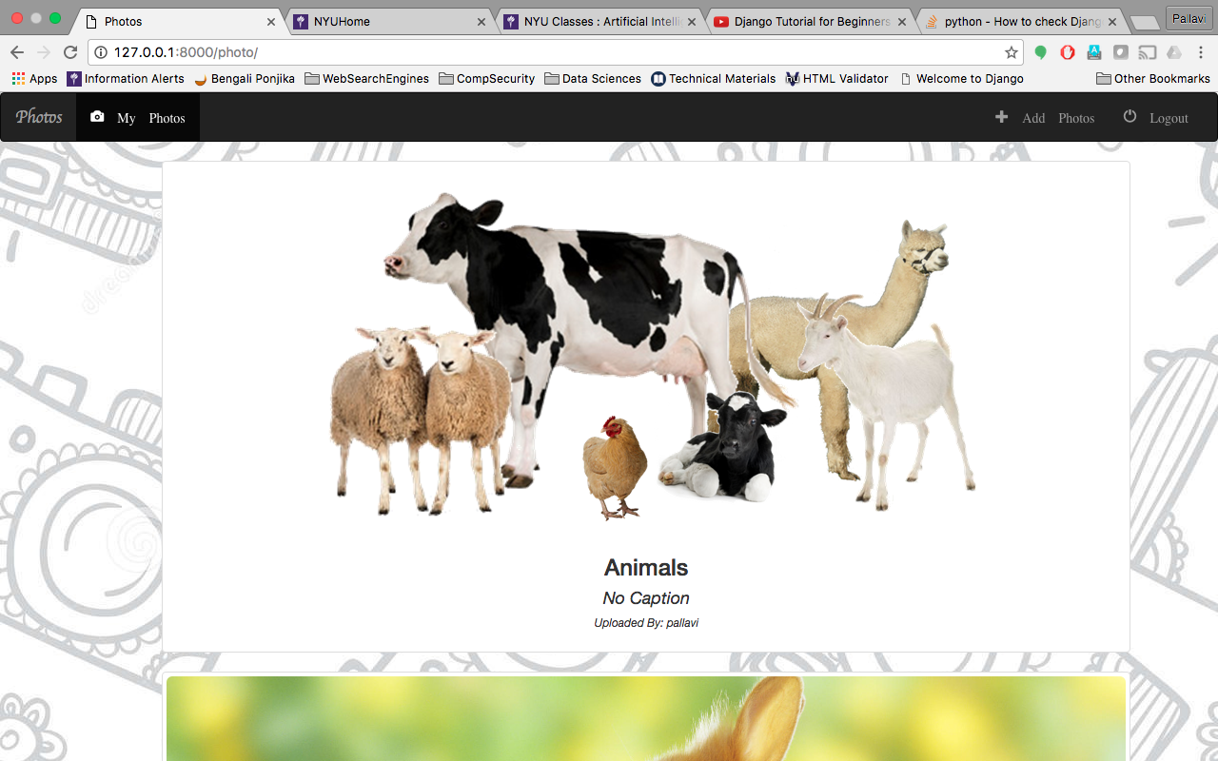

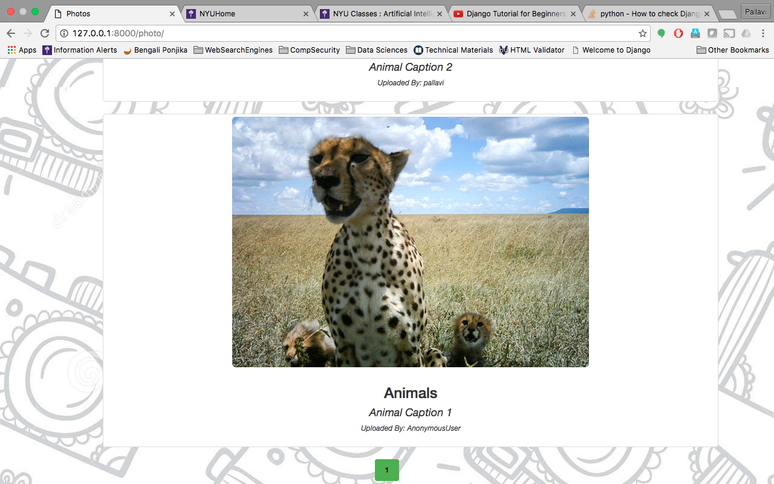

After 10 items, it moves to the next page for display. Also the display occurs chronologically the recent most first and then moving to the older ones.

## Upload Photos

The link <http://127.0.0.1:8000/photo/photo/add/> allows users to upload photos. This can be done by both authenticated and unauthenticated users. This can also be accessed by “Add Photos” in the navigation menu

Photo Upload as presented to an unauthenticated user.

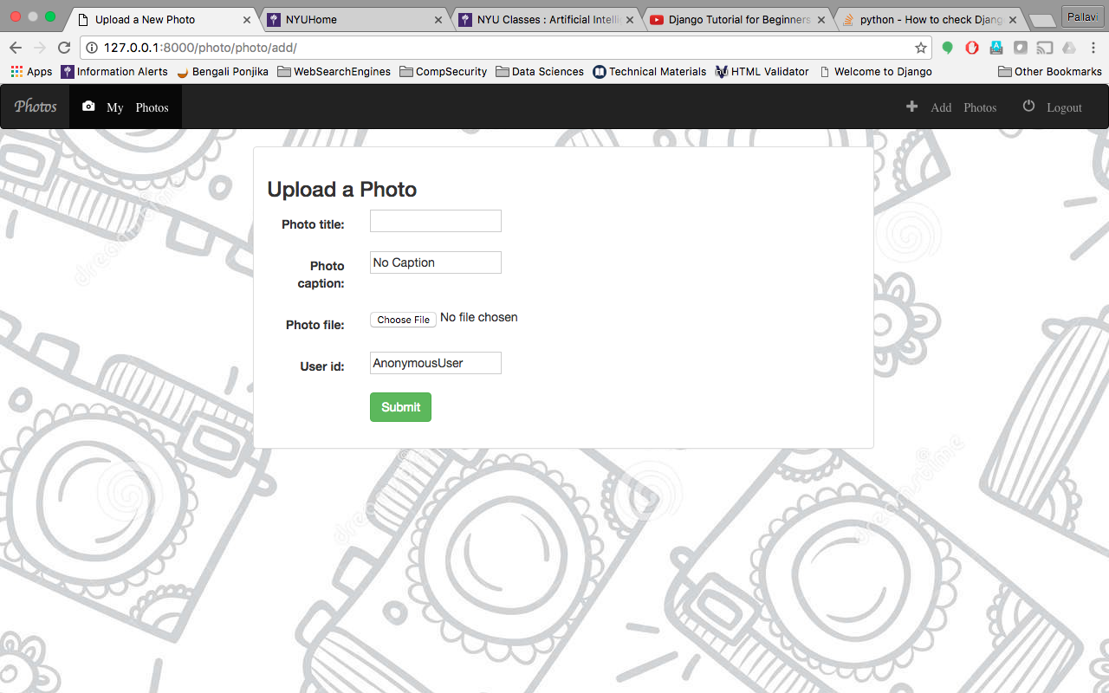

Photo Upload as presented to an authenticated user.

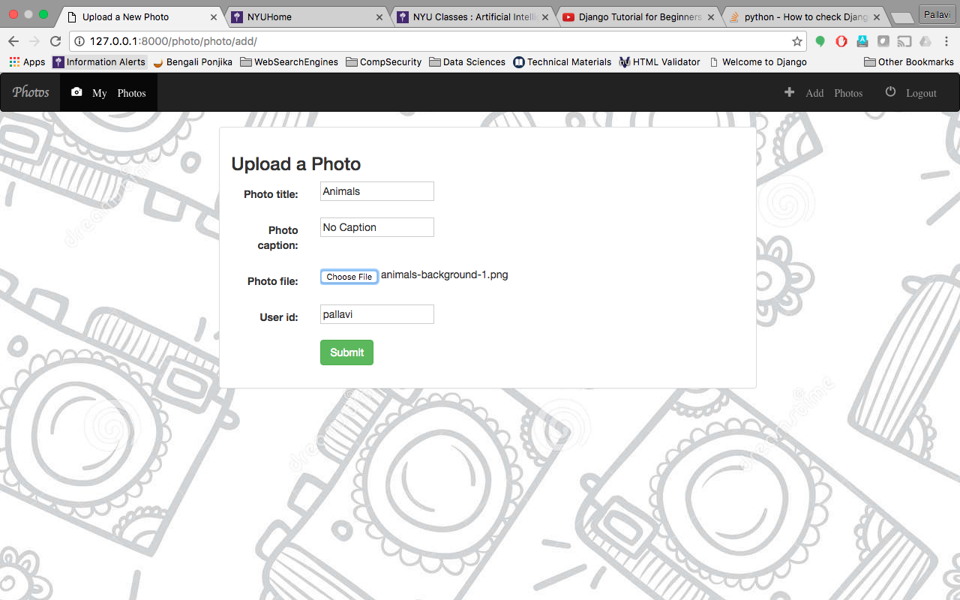

After the photo is uploaded, a view for the uploaded photo along with the details is visible.

If it is an unauthenticated user, this is the only time they can change the caption if required, after that the option does not exist. Also they cannot delete the photo.

For an authenticated user, they can go to their “My Photos” page after login and change the caption as many times as they like or delete the photo.

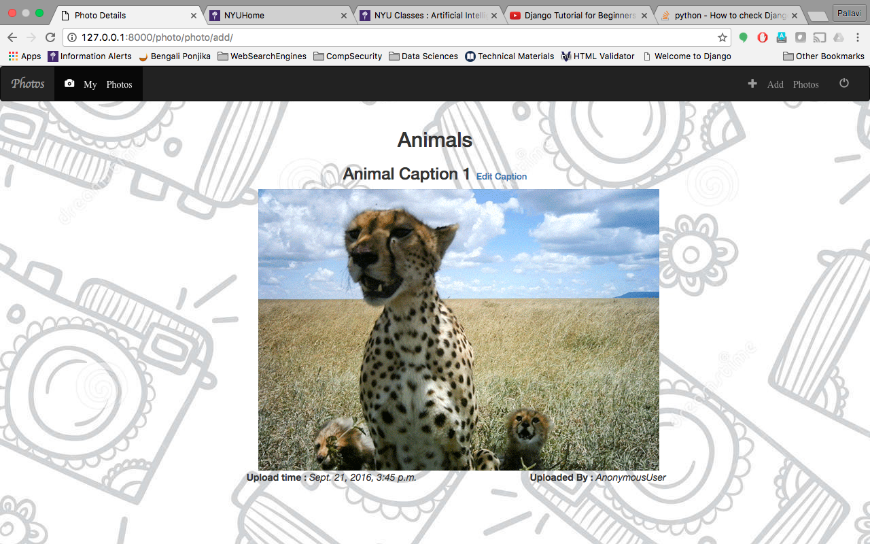

The page only allows files with PNG, JPG, JPEG or GIF extension to be uploaded, else throws an error stating the same.

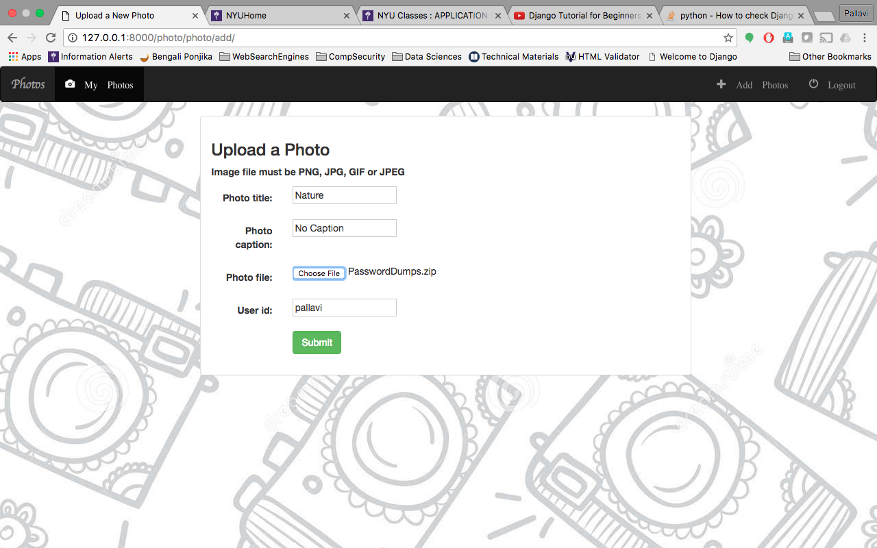

## User Photo Page

This page is accessible only to authenticated users. If an unauthenticated user tries to access this page, he/she will be prompted to login.

This can be accessed through the link <http://127.0.0.1:8000/photo/photo/myuploads/> or by clicking on “My Photos” in the Navigation Menu.

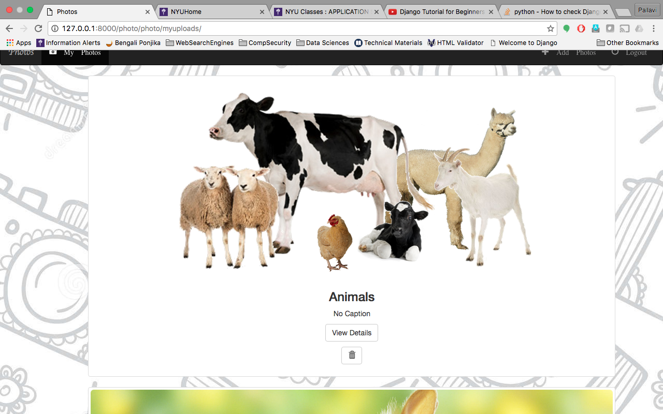

This gives an option to view all the photos uploaded by the user along with a link to “View Details” which gives option to change the caption if required. Also there is an option to delete the photo.

## Details Page

This is the page which comes up when user clicks on “View Details” on user upload page. This page is accessible using the primary key generated during the Photo object creation during photo upload

For example, for the photo with PK=17, the link to access will be http://127.0.0.1:8000/photo/17/

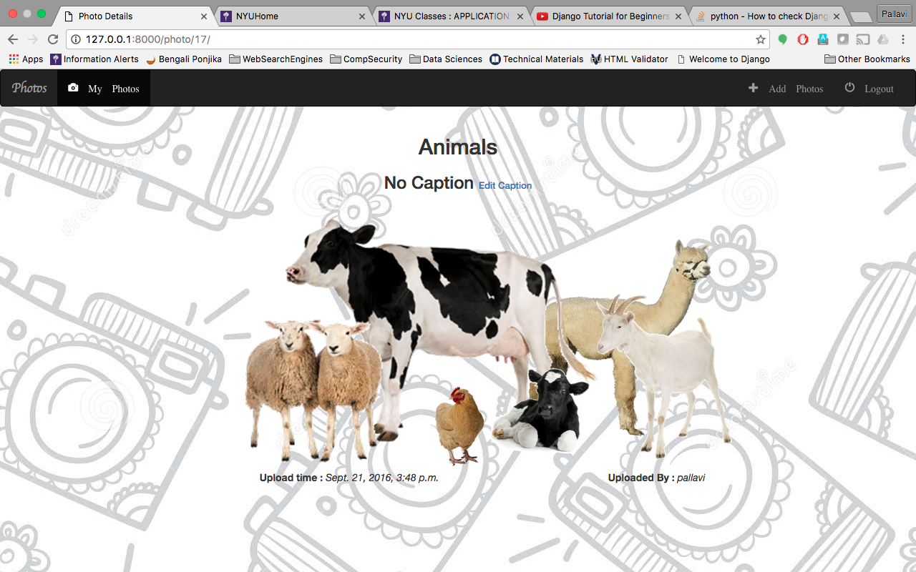

## Login and Registration Forms

Login and Registration Forms are available. Login is prompted when trying to access “My Photos” Tab or if the user clicks on “Login” tab in the top right of the navigation menu. Also when the authenticated user clicks “Logout” tab on the navigation tab, the page is redirected to Login Page.An option to register is provided in the Login page.

Login page can be accessed through the link: <http://127.0.0.1:8000/photo/login/>

Registration page can be accessed through the link: <http://127.0.0.1:8000/photo/register/>

Login Page

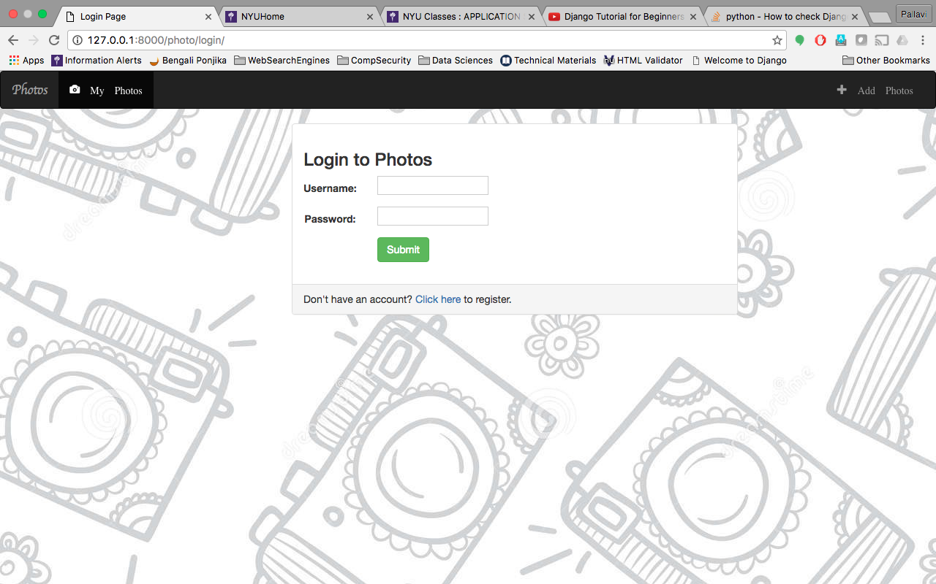

Registration Page

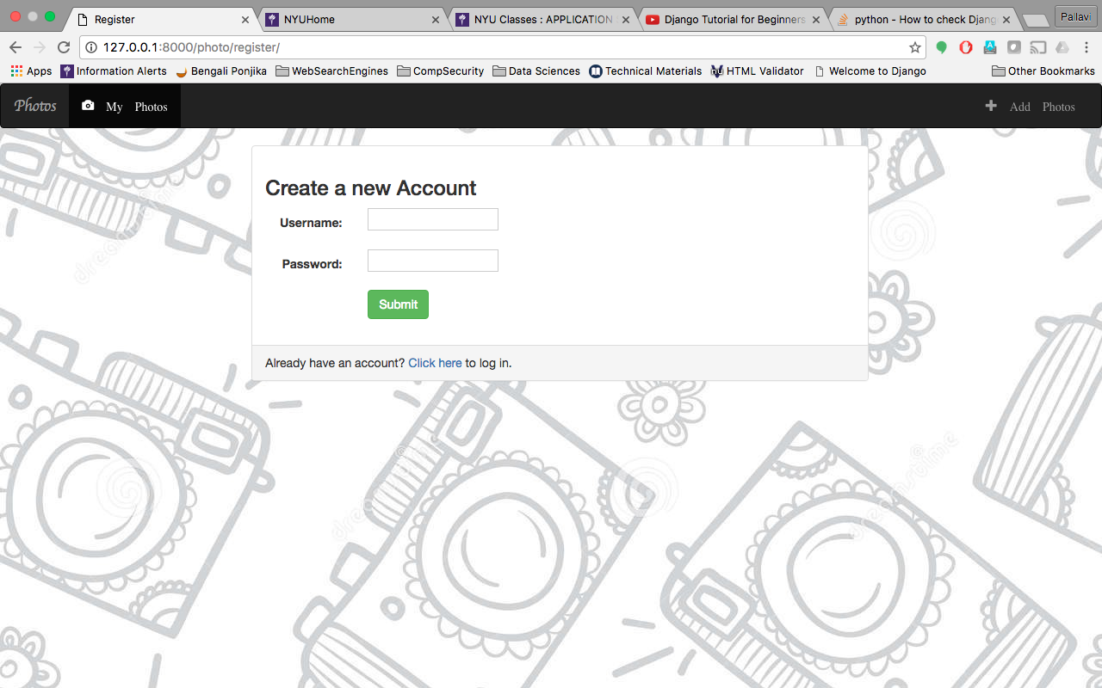

## Admin Console

The admin console is available only to super user created for the website.

Using the admin console, administration can be done on the Photos objects, this can be used for supervision, also this console can be used for user administration

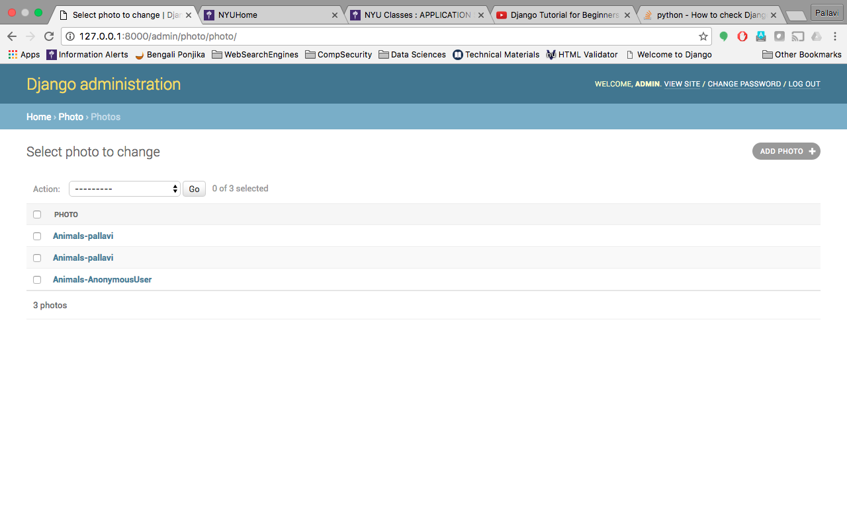

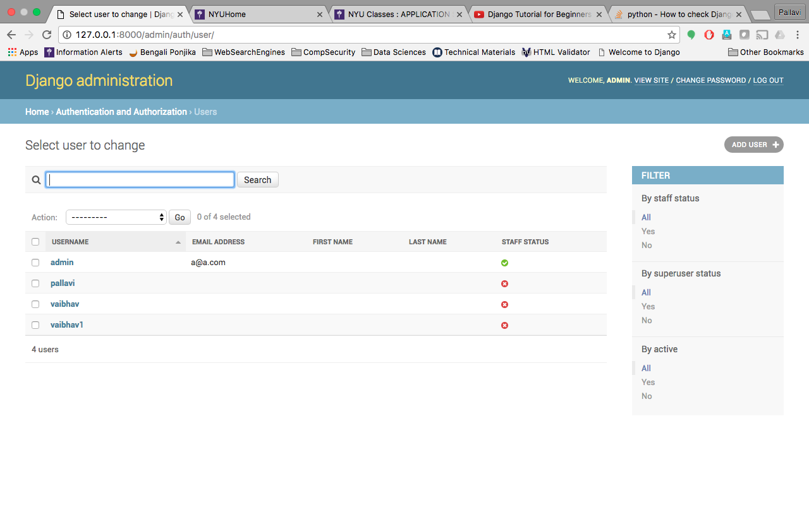

# Setup and Running of the code

For this setup to work, Python and Django need to be Installed along with mysql.

Following are the steps which need to be done in mysql:

1. Start mysql server using ***mysqld*** command.
2. Login as root : ***mysql –u root –p***. You will prompted to put the password to login.
3. Create a database called “**photoalbum**”.

Steps to be done in the code:

1. Download the code zip and unzip the same.
2. Traverse to the main folder “photoalbum”.
3. Open the file settings.py in the folder “photoalbum” folder within the main folder. Change the <username> and <password> details in the settings.py file

DATABASES = {  
 **'default'**: {  
 **'ENGINE'**: **'django.db.backends.mysql'**,  
 **'NAME'**: **'photoalbum'**,  
 **'USER'**:**<username>**,  
 **'PASSWORD'**:**<password>**,  
 }  
}

Also change the following, if any changes are required:

MEDIA_ROOT=os.path.join(BASE_DIR,**'media'**)

MEDIA_URL = **'/media/'**

## Run the code

Following steps are to be followed in order to run the code after the above setup is completed.

1. Ensure that the mysql server is up and running.
2. Open a terminal and traverse to the main folder “photoalbum”, if a “list directory” command is executed, the following should be the result confirming that you are in the correct directory.



1. Type the command “***python manage.py migrate***”. Following should be the output:

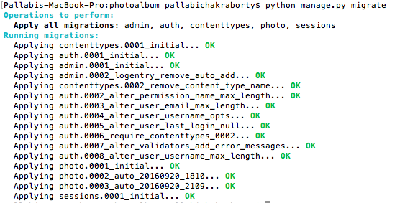

1. Type the command “***python manage.py runserver***”.

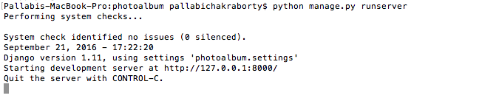

1. Open a browser and type in <http://127.0.0.1:8000/photo/>.

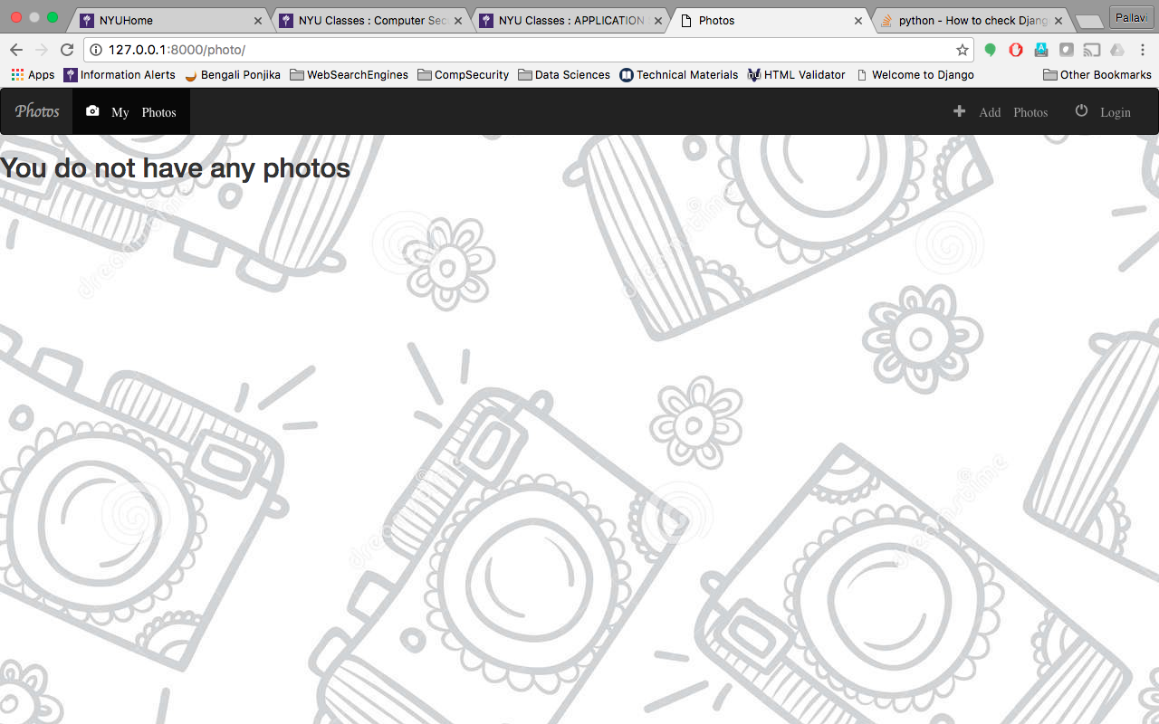

1. To create a super user, type the “***python manage.py createsuperuser***” command in the terminal

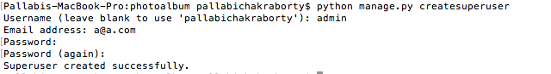

1. To test the setup, try uploading a photo without login and then register a user and try uploading a photo by an authenticated user.
2. Also try to upload more than 10 items and check if the pagination works.

For example

There are 11 photos overall in the website thus the default page overflows to the second page however there are only 10 pictures uploaded by the user thus shows only 1 page.

Default Page

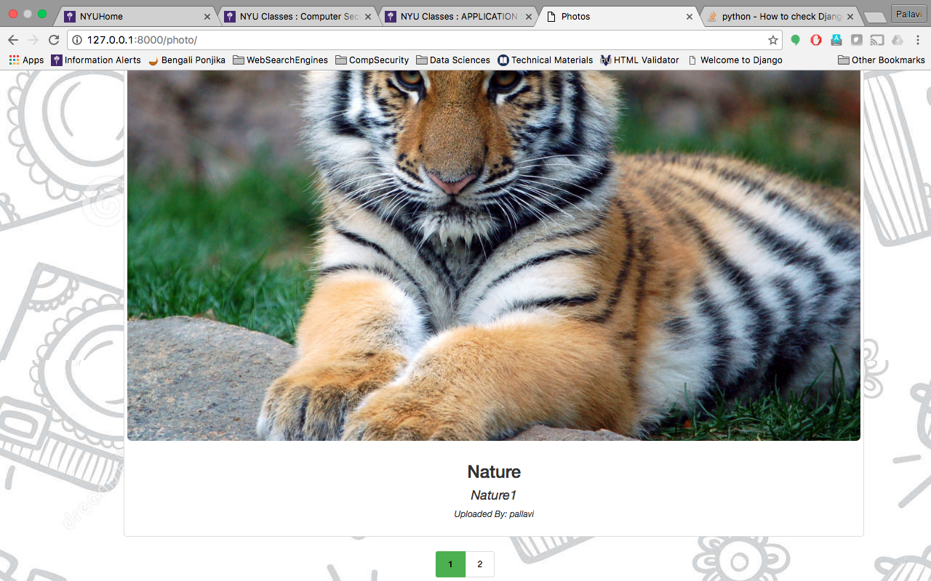

User Uploaded Photo Page

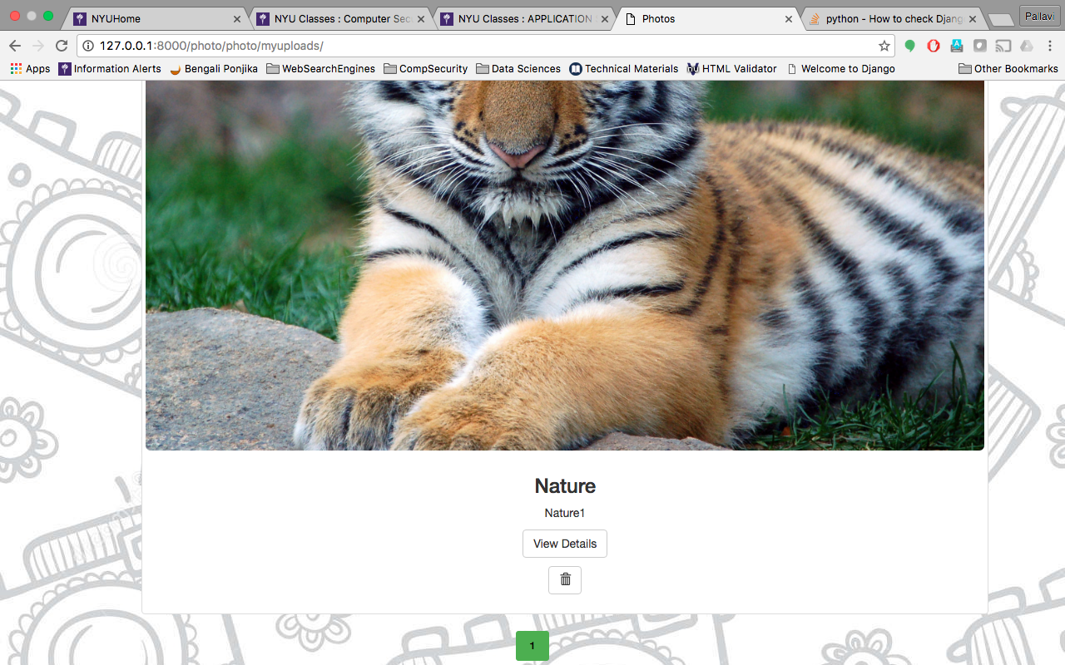

# Overview of the Design

Code has been divided into apps. The “Photos” website is developed as an app under the Django project. This follows the MVC approach.

The “photo” app is the default app being used. This contains static content, HTML templates and other supporting files separately placed so that it is easier to work on the components.

All the static content has been placed in the folder: ***photo/static***. This includes image files, Javascript files as well as CSS files.

All the HTML content has been placed in the folder: ***photo/templates***.

All supporting files are generated under the **photo** folder.

The settings file is available under the folder **photoalbum**.

# Code Walkthrough

The code is again divided in the folders “**photoalbum**” and “**photo**” within the main folder.

Following are the changes done on the default framework files.

|  |  |  |  |
| --- | --- | --- | --- |
| Folder | File Name | File Type | Utility |
| photoalbum | settings.py | Python file | This contains all the settings which are required by website to run. |
| photoalbum | urls.py | Python file | Contains the links to link the server url with the app urls. Also contains URLs for generating the static data as well the storage path of the Media files. |
| photo | urls.py | Python file | Contains relative links from the photo app to all the pages linked with the app. Following links available in the file: 1) Default Page(name = 'index') 2) Photo Detail Page (name = 'detail') 3) Upload Photo (name ='photo-add') 4) Photo Update Page (name='photo-update') 5) Photo Delete Page (name ='photo-delete') 6) User's Uploaded Photo Page (name='myuploads') 7) Registration Page (name ='register') 8) Login Page (name='login') 9) Logout Page (name='logout') |
| photo | models.py | Python file | Contains the model for the Photo object which is used to generate the database tables as well. Contains the following models: 1) Photo  Photo Object contains the following columns: 1) Title of Photo: photo_title 2) Caption of Photo: photo_caption 3) File of the Photo: photo_file 4) Photo Upload Time: photo_uploadtime 5) Upload done by User ID: user_id |
| photo | forms.py | Python file | This contains Model Forms which are used to get the data, these are used by the views to generate form objects   Following forms are created: 1) UserFrom - Fields ['username','password'] 2) PhotoForm - Fields ['photo_title', 'photo_caption', 'photo_file','user_id'] |
| photo | admin.py | Python file | Photo Object registered in the Python File to make it available in the admin Console. |
| photo | views.py | Python file | This enables in generating views employed in the urls.py to associate a particular action with a URL.  Following are the views: 1) index: This view is used to generate data for the Default Page of the Photos Website. This queries the database for all the Photo Objects and sends this information to the HTML file index.html 2) userphotoview: This view is used to generate data for authenticated user by filtering the Photo Objects on User ID and then invoke user_photo.html with this data. Unauthenticated users are redirected to Login Page 3) DetailView - This generates an object for a particular PK and then passes this information to details.html 4) photoupload - Checks if the form is valid, if valid checks for the file types of the file uploaded, if everything is found acceptable then saves the photo upload and also redirects to the details.html for a final check. 5) PhotoUpdate - Allows update of the Photo Objects.  Fields allowed for update is:  a) photo_caption 6) PhotoDelete - Deletes a particular photo and redirects to the default Photos page after success. 7) register - Registers the user if the data is acceptable and redirects to User's Photo Upload page 8) login_user - Authenticates the user and redirects to User's Own photo upload page 9) logout - Logs out and redirects to the login page |
| photo/templates/photo | index.html | HTML file | Default Page which allows users to view the photos uploaded to the site |
| photo/templates/photo | base.html | HTML file | This is the base template for all the HTML pages which can have access by both authenticated and unauthenticated users |
| photo/templates/photo | base_unauthorized.html | HTML file | This is the base template for all the HTML pages which can have access by unauthenticated users |
| photo/templates/photo | details.html | HTML file | Shows the details of a particular Photo, for example Photo Title, caption, Photo, Upload time, Uploaded By. |
| photo/templates/photo | form-template.html | HTML file | This is used to generate a basic template for any form generation using the form structures generated in forms.py |
| photo/templates/photo | login.html | HTML file | Login Page |
| photo/templates/photo | photo-form.html | HTML file | Form for Uploading Photos |
| photo/templates/photo | registration_form.html | HTML file | Form for User Registration |
| photo/templates/photo | user_photo.html | HTML file | This page outputs all the photos uploaded by a particular authenticated user. This can be viewed only by an authenticated user within their login session. |
| photo/static/photo/images | background.jpg | JPG file | Background image of the website |
| photo/static/photo | jquery.js | JS file | jquery library |
| photo/static/photo | paginate.js | JS file | This generates the pagination control dynamically using the items being uploaded. |
| photo/static/photo | style.css | CSS file | CSS file for the styling of the HTML files in the site |

# References

1. Django Reference: <https://github.com/buckyroberts/Viberr>
2. Javascript Reference: <https://github.com/LaminSanneh/Jquery-Pagination-Plugin/archive/master.zip>